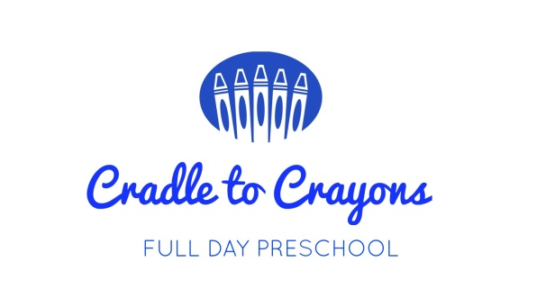
Bears 2020

Stationary list:
2 sets x Mon Ami colouring pencils (turn-up’s)
1x 8 colour Pastel crayons
1x Scissor (round nose)
4x 43 grams Pritt Glue Sticks
1x Ruler and Pencil Sharpener
2x Kirby Pencils (Triangular grip)
Jumbo wax crayons
1x Reams A4 White paper
2 x 96 page hardcover book
Jumbo colouring book
Hygiene List:
1x Medium Tub Vaseline or Aqueous Cream
12x Rolls Toilet Tissues
12x Wet wipes (1 per month)
10 x boxes Nasal Tissues
Personal Items
Clearly labelled items to remain at school:
1x Sun block and Sun Hat
R200 Printing cost for workbooks for the year. Please ensure that printing money be paid in no later than the 1st of February 2020.
Please ensure that all items on this list are clearly labelled.
Thank you, Teacher Petro

